Workshop Request Form

Cleveland Hall 306, 1300 Elmwood Avenue, Buffalo, NY 14222 cape.buffalostate.edu
(716) 878-5811 careers@buffalostate.edu

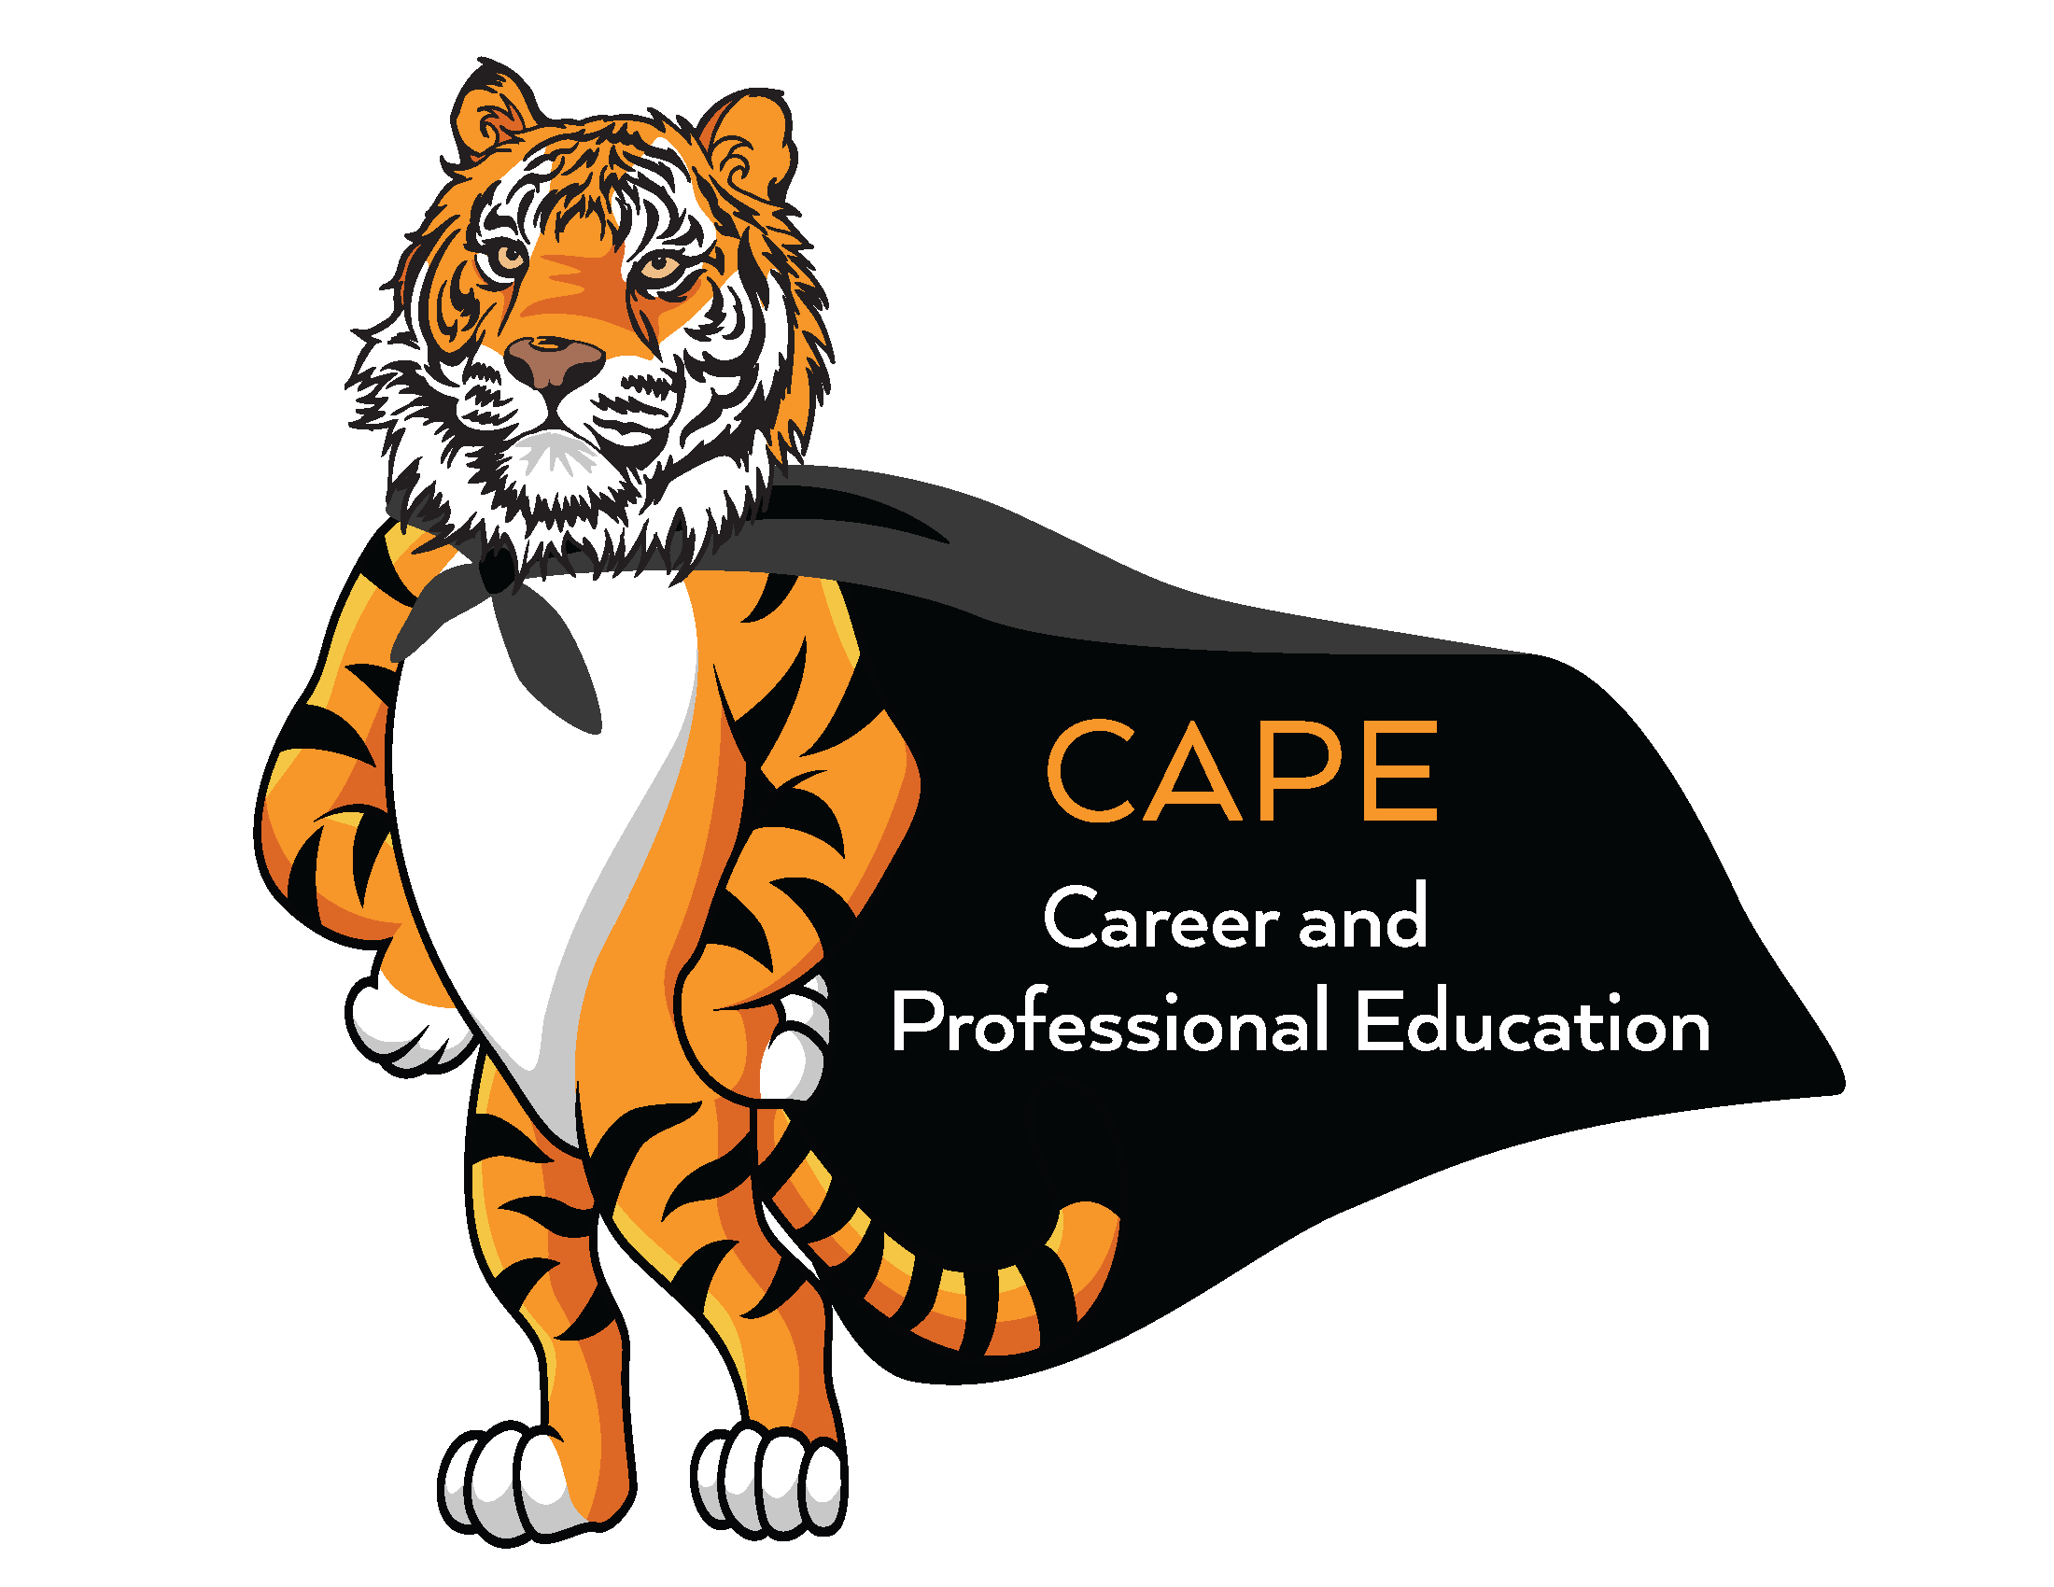
Please return to CLEV 306 upon completion. Requests will be confirmed/denied within one week of the date of the request.
(At least three weeks advance notice is recommended.)

Name: Title: Date:
Department/club/organization:
Phone numbers: Office Department Home (if appropriate)
Addresses: Campus Home (if appropriate) Email
---------------------------------------------------------------------------------------------------------------------------------------------------------------------------------------------------
TOPIC(S) REQUESTED

CAPE Services Cover Letter Writing MBTI Personality Assessment What Employers are Looking For
Resume Writing Careers In…… Choosing a Career/Major Graduate School
Networking Interviewing Conducting a Job Search Making the Most of an Internship
LinkedIn Developing Professional Skills Other
---------------------------------------------------------------------------------------------------------------------------------------------------------------------------------------------------
Class title/organization name:
Group characteristics: Freshmen Sophomores Juniors Seniors Graduate Students Other
Other characteristics: e.g. majors(s) Approx. no. of students
Workshop location and characteristics: Bldg. Room
Please indicate the available technology: No Smart Classroom Smart Classroom Smart Board Laptop/Net Cart
PC Apple Document Camera Overhead Projector
Address if off campus:
List three dates and times in order of preference:
DAY DATE START TIME END TIME
1st Choice
2nd Choice
3rd Choice

NOTES:

WORKSHOP REQUEST CONFIRMATION - FOR OFFICE USE ONLY
Today's date Request taken by (CAPE staff)

Workshop presenter

Scheduled on from to
(day) (date) (time) (time)

Confirmed/regretted by phone/e-mail/in person by on
(circle one) (circle one) (initials) (date)
01/23

